Time Zone

Definition:
# Source: AI Source: Provided by: [Data Path: Persons Table -> ID Column: 1, Name_En Column: Motasem Essam] -> From: [Chatgpt (GPT‑5 Mini)] on [1/26/2026]
A time zone is a region of the Earth that has the same standard time. Time zones are usually defined as offsets from Coordinated Universal Time (UTC).

Key Points
# Source: AI Source: Provided by: [Data Path: Persons Table -> ID Column: 1, Name_En Column: Motasem Essam] -> From: [Chatgpt (GPT‑5 Mini)] on [1/26/2026]
- Offset from UTC: Each time zone is expressed as UTC±X hours.
  - Example: UTC+5:30 → India Standard Time (IST)
  - UTC-8 → Pacific Standard Time (PST)
- Daylight Saving Time (DST): Some time zones adjust clocks forward or backward during certain months.
- Purpose: Time zones exist because the Earth rotates 360° in 24 hours, so local time differs by longitude.
- Global Coordination: Time zones help coordinate activities, travel, and communication worldwide.

Example of Time Zones
# Source: AI Source: Provided by: [Data Path: Persons Table -> ID Column: 1, Name_En Column: Motasem Essam] -> From: [Chatgpt (GPT‑5 Mini)] on [1/26/2026]
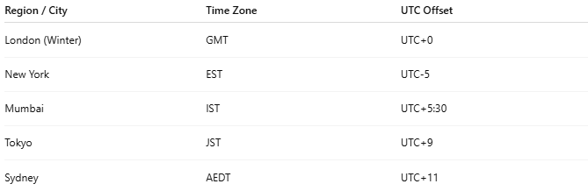
Region / City | Time Zone | UTC Offset
London (Winter) | GMT | UTC+0
New York | EST | UTC-5
Mumbai | IST | UTC+5:30
Tokyo | JST | UTC+9
Sydney | AEDT | UTC+11

How Time Zones Work
# Source: AI Source: Provided by: [Data Path: Persons Table -> ID Column: 1, Name_En Column: Motasem Essam] -> From: [Chatgpt (GPT‑5 Mini)] on [1/26/2026]
- Earth is divided into 24 time zones, roughly 15° of longitude each.
- When it’s 12:00 PM UTC, it is:
  - 5:30 PM in India (UTC+5:30)
  - 7:00 AM in New York (UTC-5)

Analogy
# Source: AI Source: Provided by: [Data Path: Persons Table -> ID Column: 1, Name_En Column: Motasem Essam] -> From: [Chatgpt (GPT‑5 Mini)] on [1/26/2026]
- UTC → Master clock
- Time zone → Local clock set according to the master clock, adjusted for local position on Earth

Usage
# Source: AI Source: Provided by: [Data Path: Persons Table -> ID Column: 1, Name_En Column: Motasem Essam] -> From: [Chatgpt (GPT‑5 Mini)] on [1/26/2026]
- Scheduling international meetings
- Setting clocks in computers, smartphones, and servers
- Aviation, shipping, and communication rely on time zones for coordination

✅ Summary
# Source: AI Source: Provided by: [Data Path: Persons Table -> ID Column: 1, Name_En Column: Motasem Essam] -> From: [Chatgpt (GPT‑5 Mini)] on [1/26/2026]
- Time zone = region sharing the same standard time
- Defined as offset from UTC
- Helps coordinate time across the world

